**AMERICAN INTERNATIONAL UNIVERSITY–BANGLADESH (AIUB)**

**FACULTY OF SCIENCE & TECHNOLOGY**

**Spring 2022-2023**

**Section: J, Group:6**

**LAB REPORT: 01**

**Supervised By: SADMAN SHAHRIAR ALAM**

**Date of Submission: 11.02.2023**

**Submitted by: Sirajus Salehin(ID:21-44543-1), Group 6**

**Title:** Introduction to MATLAB

**Abstract:**

Different MATLAB operations and functions will be performed in this experiment. The purpose of this experiment is to develop an understanding of the MATLAB environment, commands and syntax as well as how to use it to solve communication engineering problems. The experiment was conducted using MATLAB software. All the objectives were successful. It helped us with a better understanding of the MATLAB environment and usage.

**Apparatus:**

MATLAB2016a

**Performance Task:**

My ID: 21-44543-1 = AB-CDEFG-H

So,

A1= AB= 2*1=2

A2= GH=3*1=3

J1=DG=(4*3)*pi/180

J2= 30*pi/180

F=CDEF=4*4*5*4=320

Fs= 320*20=6400

X1=2*cos(2*pi*(1/6400)*t)+J1

subplot(3,1,1)

plot(t,X1)

xlabel('time')

ylabel('Amplitude')

title('X1 Graph')

X2=3*cos(2*pi*(1/6400)*t)+J2

subplot(3,1,2)

plot(t,X2)

xlabel('time')

ylabel('Amplitude')

title('X2 Graph')

X3=X1+X2

subplot(3,1,3)

plot(t,X3)

xlabel('time')

ylabel('Amplitude')

title('X3=X1+X2 Graph')

**Simulations:**

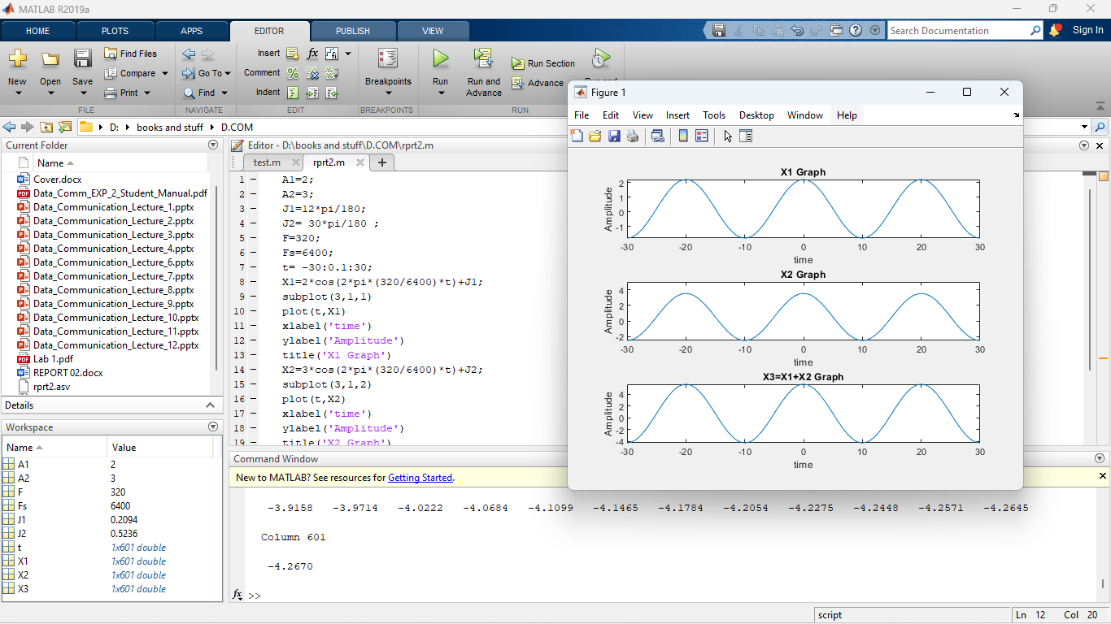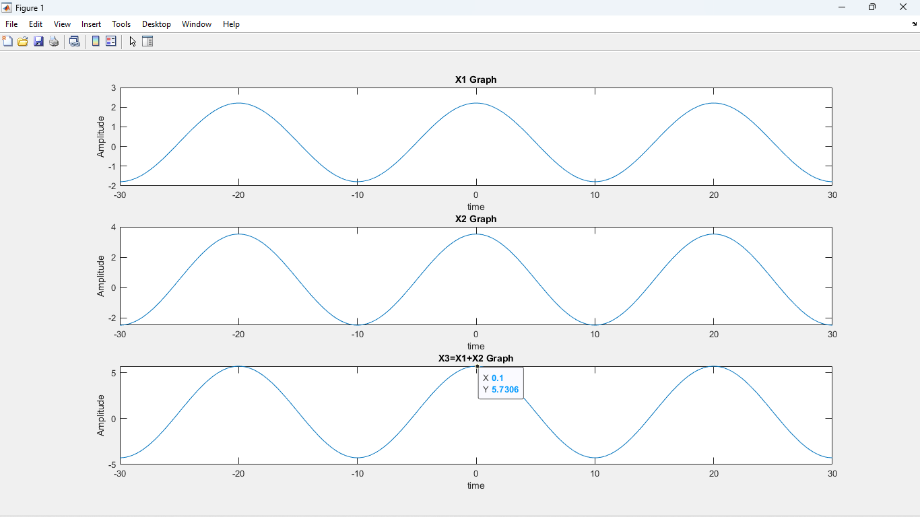

**Magnitude = 5.7306**

**From the plot, we can see, x3(t) completes one cycle in 20 s**

**Discussion:**

As per the objective, different MATLAB operations were performed which helped us with a better understanding of the MATLAB environment, commands and syntax as well as how to use it to solve communication engineering problems.

**Conclusion:**

The purpose of this experiment was to develop an understanding of the MATLAB environment, commands and syntax as well as how to use it to solve communication engineering problems. We were able the accomplish all the objectives. In the lab, we had some trouble using MATLAB software, after following the faculty’s instructions it was resolved. In this experiment, we performed basic MATLAB operations, plotting’s, and functions. Perhaps this experiment could be improved by verifying the results using other software and by comparing them. This experiment shows that MATLAB is very essential for solving complex mathematical and data communication problems. It is very easy to use, and it saves us a lot of time and its results are very accurate.

**REFERENCE:**

1. MATLAB user guide.

2. Prof. Dr.-Ing. Andreas Czylwik, “MATLAB for Communications”